**THE MAHARAJA SAYAJIRAO UNIVERSITY OF BARODA**

Faculty of Science



**5th semester Mini Project Report**

*On*

***PAIGE (Buy, Sell and Rent Used Books)***

*Guided by*

**Mr. Kshitij Tripathi**

*In fulfillment of the degree*

*Of*

**Bachelors of Computer Applications**

*In*

**Department of computer Applications**

**Submitted by**:

kamakshi Nanda -522042 Riddhi Batas -522006

Pruthvin Jhaveri-522026

Jayati Goswami-522021

**The Maharaja Sayajirao University of Baroda**

**Faculty of Science**

**Department of Computer Applications.**

**Abstract**

The business-to-consumer aspect of electronic commerce (e-commerce) is the most visible business use of the World Wide Web. The primary goal of an e-commerce site is to sell goods and services online.

This project deals with developing an e-commerce website for Online Book Sale. It provides the user with a catalogue of different books available for purchase in the store. In order to facilitate online purchase a shopping cart is provided to the user. The system is implemented using a 3-tier approach, with a backend database, a middle tier of server and JSP, and a web browser as the front end client.

In order to develop an e-commerce website, a number of Technologies must be studied and understood. These include multi-tiered architecture, server and client side scripting techniques, implementation technologies such as JSP, programming language (such as JAVA, JavaScript, and HTML), relational databases (such as MySQL, Access).

This is a project with the objective to develop a basic website where a consumer is provided with a shopping cart application and also to know about the technologies used to develop such an application.

This document will discuss each of the underlying technologies to create and implement an e-book store.

**Acknowledgment**

In completing this mini project, we have been fortunate to have help, support and encouragement from many people. We would like to acknowledge them for their cooperation.

First of all we would like to thank almighty for his grace and love showered on us. Secondly we thank **Prof. S.R.Srivastava (H.O.D.)** who gave us this opportunity to work for the project which will add to our experience and for giving us a chance to prove our knowledge skill and abilities. Then we would like to thank **Mr. Biraj Shah**, our project advisor, for guiding us through each and every step of the process with knowledge and support. Thank you for your advice, guidance and assistance.

We would also like to thank **Mr. Kshitij Tripathi** who showed immense patience and understanding throughout the project and provided suggestions.

Not missing to thank our own **C.A. Department**, for giving us this opportunity to gain practical experience and enable us to understand the demand of the experience and professional environment. We have gained valuable experience which has given us confidence and has enhanced our professional skill for our competent career.

We would also like to thank all our teachers and family members and friends for helping, bearing, encouraging and boosting our morale, throughout our studies, especially during the project period. Last but not the least we would like to express our sincere gratitude to those who helped us in completing our project directly or indirectly.

**Business Problem**

In the world of software development there lots of improvement in the area of

Architectural design and principles. The philosophies and implementation details are

changing as the people guiding the development of the application. In this fantastic

and yet sometimes complex world of software development there are some tried and

true architecture patterns and software development guidelines employed by most

architects. Also your design must have an ability to turn towards innovation instead of

lending itself to common practices. Web services are one such area where architects

must lean on their creative side and hope that their solutions are still successful. In

this report we will explain an exciting voyage down the road of Web services

application. From requirements to use cases, to database design, to component

frameworks, to user interfaces, we will cover each and every aspect of system design

required to build an application with collaborative Web services. The reason why we

selected online Bookstore web service is everybody walking down the street has some

idea about bookstores. The objective of this project is to develop an e- book store

where books can be bought from the comfort of home through the Internet.

An online book store is a virtual store on the Internet where customers can browse the

catalogue and select books of interest. The selected books may be collected in a

shopping cart. At checkout time, the items in the shopping cart will be presented as an

order.

**Table of Contents**

1. Project Charter…………………………………………………………………
   1. Project Definition……………………………………………………...
   2. Purpose………………………………………………………………...
   3. Scope of Project…………………………………………………………
   4. Team Size…………………………………………………..
2. Project Plan……………………………………………………………
   1. Objective………………………………………………………
   2. Software Model-Traditional……………………………………………
   3. Work division (w.r.t time)……………………………………
   4. Work division (w.r.t team members)……………………………….
3. Hardware and Software Requirements………………………………………….
4. Tools and Technologies Used…………………………………………………
5. Requirement Analysis and System Analysis………………………………….
   1. Module Specification……………………………………………………
   2. System Flow……………………………………………………………
      1. Use case diagram……………………………………………….
      2. Activity diagram………………………………………………..
      3. Sequence diagram…………………………………………….
   3. Data Modeling…………………………………………………………
      1. Data Dictionary………………………………………………..
      2. Class Diagram………………………………………………….
6. System Design………………………………………………………………….
   1. Database Design…………………………………………………………
      1. Table and relationships………………………………………….
   2. Interface Design………………………………………………………..
      1. Screenshots and Explanations…………………………………….
7. Testing………………………………………………………………………….
   1. Test Plan……………………………………………………………
   2. Test methods………………………………………………………
   3. Test cases………………………………………………………
   4. Bug Fixing/test report…………………………………………………
8. Security Features………………………………………………………………
9. Coding standards Followed…………………………………………………….
10. Limitations and Future Enhancements…………………………………………
11. Experience and learning……………………………………………………….
12. References and Bibliography………………………………………………….

**Project Charter**

**1.Project Definition:**

Online buying, selling and renting of second hand or used books.

**2.Purpose:**

* To sell, rent or shop while being in the comfort of your own home, without having to step out of door.
* Add your favorite products in the wish list and get notified every time any related product is found.
* Connect directly with the seller, chat and then decide the next step.
* Meet the seller at your mutually decided date, time and venue.
* Search for books directly and get instant results.

**3.Project Scope:**

The Online book store with the specifications of buy, sell and rent is easy to maintain, ready to run, scalable, affordable and reliable cost saving tool from software associates suited for every business.

The proposed system can be used even by the naïve users and it does not require any educational level, experience and technical expertise in computer field but it will be of good use if the user has the good knowledge of how to operate a mobile/computer device.

It consists of various features such as:

1. Sell Book
2. Buy Book
3. Rent
4. Wish list
5. Chat box
6. Book Suggestions Using Cookies
7. The user can only view books if he/she has not registered into our web application.
8. The user can login to buy ,sell and rent books.
9. If the user selects to sell the book, he will have to click on the sell option and then will have to fill a form that asks for information about the book. If everything goes well then the book will be added in our database and will be available on the Web application.
10. If the user wants to buy or rent a book he/she can surf or search books by their category, book name, ISBN, author etc.
11. The buyer and seller can contact each other using our chat box or by email or phone.

**4.Team Size:**

1. people

**Project Plan**

**1.Objective:**

To develop a working full-fledge e-commerce website for buying, selling and renting second hand or used books.

**2.Software Model-Traditional:**

* We have used incremental model to create our application.
* We gathered client’s requirements, then created a prototype and then kept changing the software in each increment according to the Incremental approach.

**3.Work division (w.r.t time):**

1. Kamakshi Nanda – 1000hrs
2. Riddhi Batas-700hrs
3. Pruthvin Jhaveri-600hrs
4. Jayati Goswami-700hrs

**4.Work division (w.r.t team members):**

1. Kamakshi Nanda-Backend, frontend, documentation, database
2. Riddhi Batas-Backend, documentation, frontend, database
3. Pruthvin Jhaveri-Frontend, documentation, database, backend
4. Jayati Goswami-Frontend, database, documentation, backend

**Hardware and Software Requirements**

**1.Hardware:**

1. Laptops/PCs

**2.Software:**

1. NetBeans with Tomcat Server
2. PHP my admin
3. Bootstrap Studio
4. Dreamweaver2019
5. Notepad
6. Microsoft Word 2017
7. Draw.io

**Tools and Technologies Used**

1. **Front end** 
   1. Language: HTML, CSS, JavaScript, Bootstrap
   2. Tool: Notepad++, Bootstrap Studio, Dreamweaver2019
2. **Back end**
   1. Language: Java
   2. Tool: Net beans
   3. Database: MySQL
   4. Server: Tomcat/GlassFish

**Requirement Analysis and System Analysis**

**1.Module Specification:**

1. **Registration**
2. **Login**
3. **Search Book**
4. **Buy/Rent Book**
5. **Edit Profile**
6. **Chat Box**
7. **Sell Book**
8. **Home page with product catalog**

**2. System Flow:**

**1. Use Case Diagram:**



**2.Activity Diagram:**







**3.Sequence diagram:**

1. **Registration:**



1. **Sell Book:**



1. **Buy/Rent Book:**



**3.Data Modeling:**

1. **Data Dictionary:**

# book

|  |  |  |  |  |
| --- | --- | --- | --- | --- |
| **Column** | **Type** | **Null** | **Default** | **Comments** |
| ISBN *(Primary)* | varchar(13) | No |  |  |
| title | varchar(100) | No |  |  |
| image | text | No |  |  |
| author | varchar(80) | No |  |  |
| publisher | varchar(80) | No |  |  |
| published | varchar(80) | No |  |  |
| category | varchar(100) | No |  |  |
| description | longtext | No |  |  |
| pageCount | varchar(10) | No |  |  |
| averageRating | varchar(10) | No |  |  |
| ratingsCount | varchar(10) | No |  |  |
| maturityRating | varchar(20) | No |  |  |

**Indexes**

|  |  |  |  |  |  |  |  |  |
| --- | --- | --- | --- | --- | --- | --- | --- | --- |
| **Keyname** | **Type** | **Unique** | **Packed** | **Column** | **Cardinality** | **Collation** | **Null** | **Comment** |
| PRIMARY | BTREE | Yes | No | ISBN | 0 | A | No |  |

# Languagecodes

|  |  |  |  |  |
| --- | --- | --- | --- | --- |
| **Column** | **Type** | **Null** | **Default** | **Comments** |
| code | varchar(2) | No |  |  |
| language | varchar(20) | No |  |  |

# Ratings

|  |  |  |  |  |
| --- | --- | --- | --- | --- |
| **Column** | **Type** | **Null** | **Default** | **Comments** |
| sId *(Primary)* | varchar(10) | No |  |  |
| bId *(Primary)* | varchar(10) | No |  |  |
| rating | int(11) | No |  |  |
| review | text | No |  |  |

**Indexes**

|  |  |  |  |  |  |  |  |  |
| --- | --- | --- | --- | --- | --- | --- | --- | --- |
| **Keyname** | **Type** | **Unique** | **Packed** | **Column** | **Cardinality** | **Collation** | **Null** | **Comment** |
| PRIMARY | BTREE | Yes | No | sId | 0 | A | No |  |
| bId | 0 | A | No |
| bId | BTREE | No | No | bId | 0 | A | No |  |

# Seller

|  |  |  |  |  |
| --- | --- | --- | --- | --- |
| **Column** | **Type** | **Null** | **Default** | **Comments** |
| id *(Primary)* | varchar(10) | No |  |  |
| mobNo | varchar(10) | No |  |  |
| state | varchar(50) | No |  |  |
| city | varchar(20) | No |  |  |
| pincode | varchar(6) | No |  |  |
| displayPhone | tinyint(1) | No |  |  |
| displayEmail | tinyint(1) | No |  |  |

**Indexes**

|  |  |  |  |  |  |  |  |  |
| --- | --- | --- | --- | --- | --- | --- | --- | --- |
| **Keyname** | **Type** | **Unique** | **Packed** | **Column** | **Cardinality** | **Collation** | **Null** | **Comment** |
| PRIMARY | BTREE | Yes | No | id | 0 | A | No |  |
| mobNo | BTREE | Yes | No | mobNo | 0 | A | No |  |

# Sellerbook

|  |  |  |  |  |
| --- | --- | --- | --- | --- |
| **Column** | **Type** | **Null** | **Default** | **Comments** |
| ID *(Primary)* | varchar(10) | No |  |  |
| ISBN *(Primary)* | varchar(13) | No |  |  |
| uploadDate | datetime | No |  |  |
| category | varchar(30) | No |  |  |
| bookCondition | varchar(30) | No |  |  |
| language | varchar(20) | No |  |  |
| binding | varchar(20) | No |  |  |
| frontCover | longblob | No |  |  |
| backCover | longblob | No |  |  |
| indexPage | longblob | No |  |  |
| isbnPage | longblob | No |  |  |
| randomPage | longblob | No |  |  |
| description | text | No |  |  |
| originalPrice | int(11) | No |  |  |
| sellingPrice | int(11) | No |  |  |
| rent PerDay | int(11) | No |  |  |

|  |  |  |  |  |  |  |  |  |
| --- | --- | --- | --- | --- | --- | --- | --- | --- |
| **Keyname** | **Type** | **Unique** | **Packed** | **Column** | **Cardinality** | **Collation** | **Null** | **Comment** |
| PRIMARY | BTREE | Yes | No | ID | 0 | A | No |  |
| ISBN | 0 | A | No |
| ISBN | BTREE | No | No | ISBN | 0 | A | No |  |

# Indexes

# user

|  |  |  |  |  |
| --- | --- | --- | --- | --- |
| **Column** | **Type** | **Null** | **Default** | **Comments** |
| id *(Primary)* | varchar(10) | No |  |  |
| fullName | varchar(254) | No |  |  |
| Email | varchar(254) | No |  |  |

**Indexes**

|  |  |  |  |  |  |  |  |  |
| --- | --- | --- | --- | --- | --- | --- | --- | --- |
| **Keyname** | **Type** | **Unique** | **Packed** | **Column** | **Cardinality** | **Collation** | **Null** | **Comment** |
| PRIMARY | BTREE | Yes | No | id | 0 | A | No |  |

# Validategoogleuser

|  |  |  |  |  |
| --- | --- | --- | --- | --- |
| **Column** | **Type** | **Null** | **Default** | **Comments** |
| id *(Primary)* | varchar(10) | No |  |  |
| idToken | longtext | No |  |  |

**Indexes**

|  |  |  |  |  |  |  |  |  |
| --- | --- | --- | --- | --- | --- | --- | --- | --- |
| **Keyname** | **Type** | **Unique** | **Packed** | **Column** | **Cardinality** | **Collation** | **Null** | **Comment** |
| PRIMARY | BTREE | Yes | No | id | 0 | A | No |  |

# Validatepassword

|  |  |  |  |  |
| --- | --- | --- | --- | --- |
| **Column** | **Type** | **Null** | **Default** | **Comments** |
| id *(Primary)* | varchar(10) | No |  |  |
| password | varchar(64) | No |  |  |

**Indexes**

|  |  |  |  |  |  |  |  |  |
| --- | --- | --- | --- | --- | --- | --- | --- | --- |
| **Keyname** | **Type** | **Unique** | **Packed** | **Column** | **Cardinality** | **Collation** | **Null** | **Comment** |
| PRIMARY | BTREE | Yes | No | id | 0 | A | No |  |

1. **Class Diagram:**



**System Design**

**1.Database Design:**

1. **Table and relationships:**

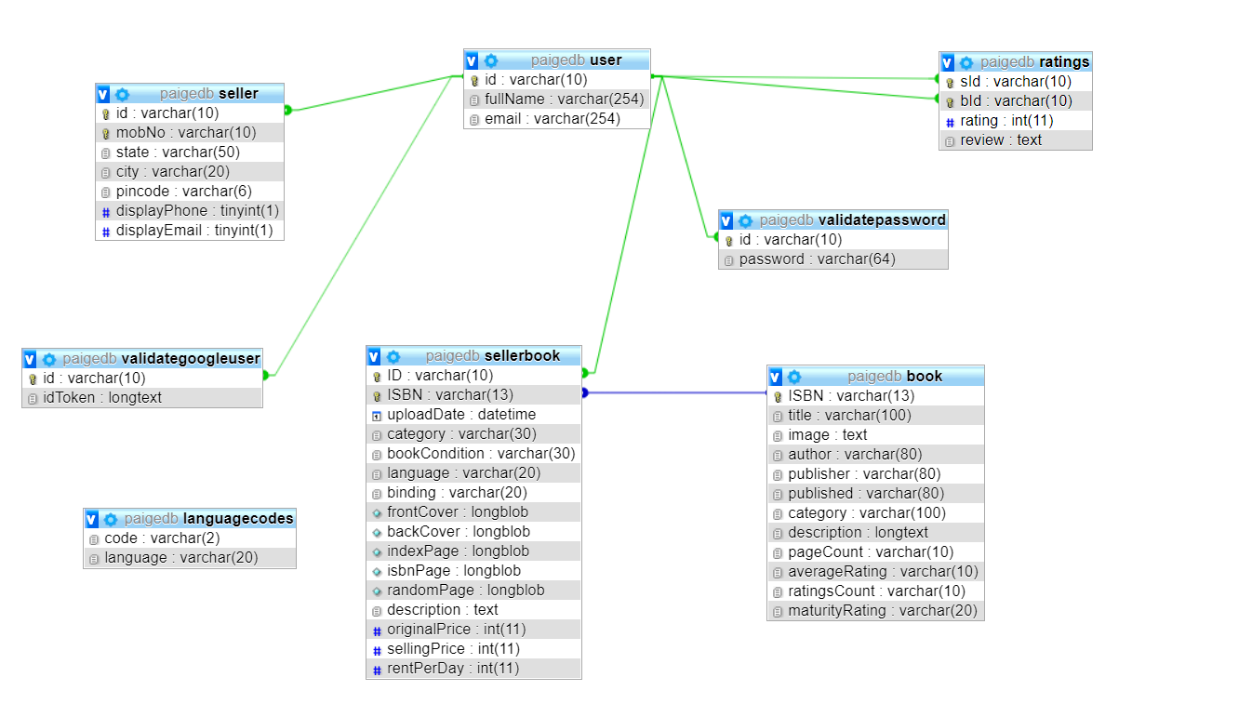

**2.Interface Design:**

1. **Screenshots and Explanations:**

**Homepage**

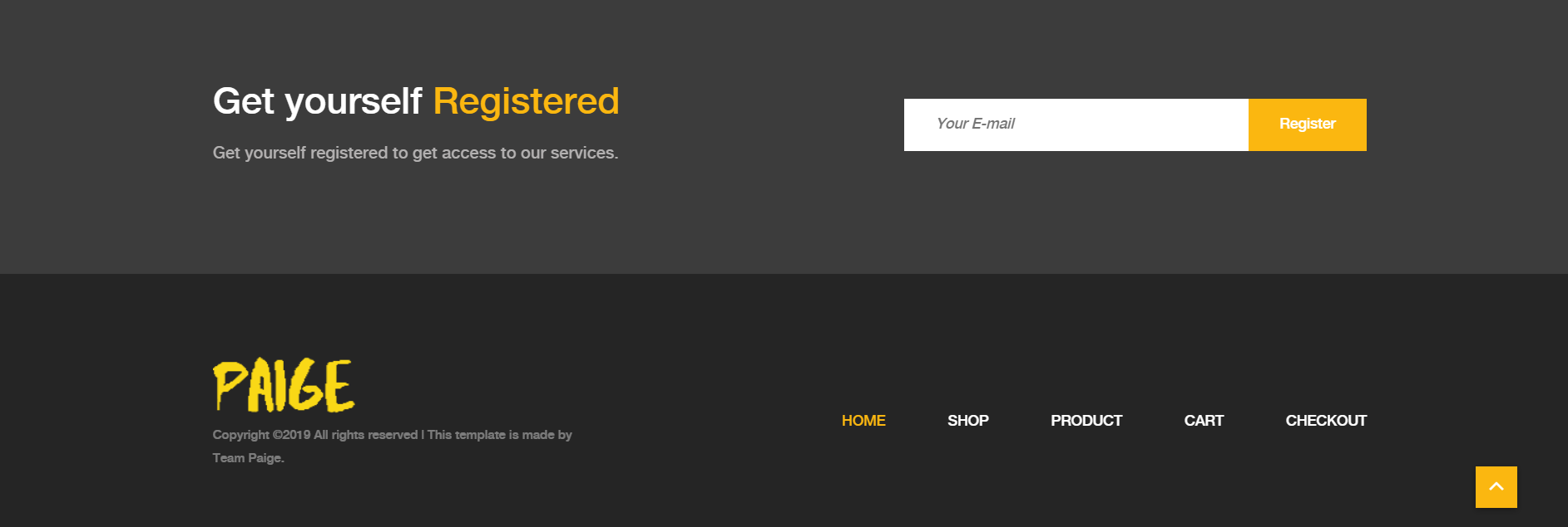

View in mobile

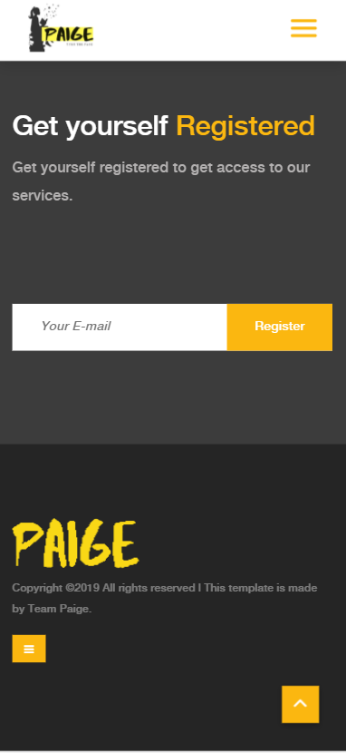

1. From the homepage user can select any category and view books in that category.
2. The user can also navigate to other pages i.e. “shop”, ”sell”, ”wish list”, “login/signup” etc through the side navigation bar.

**Shop**

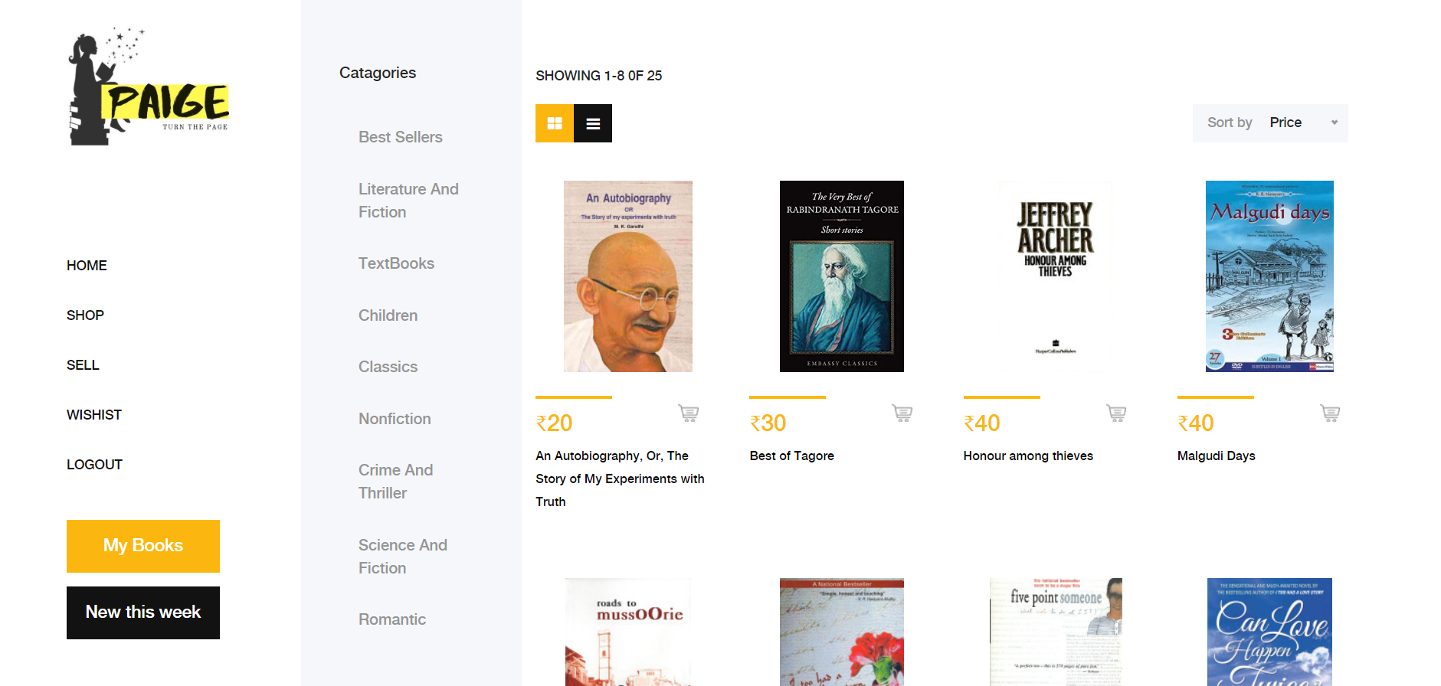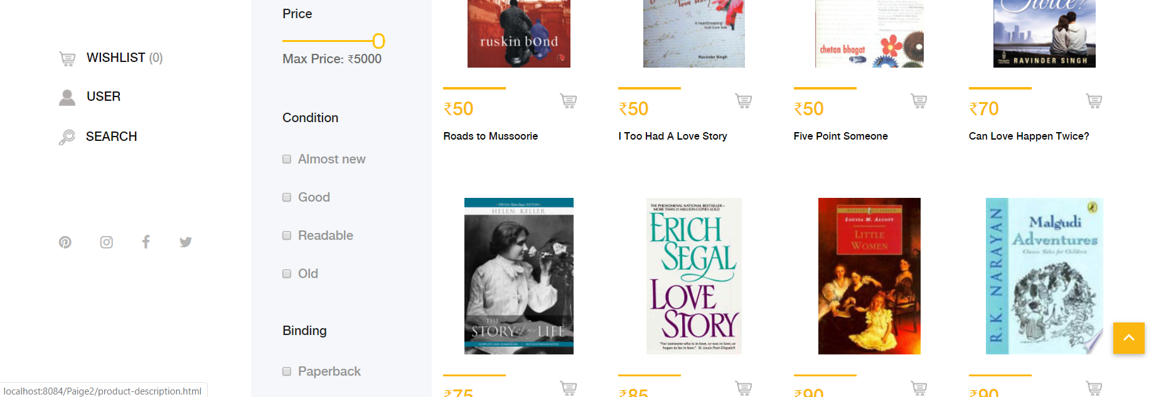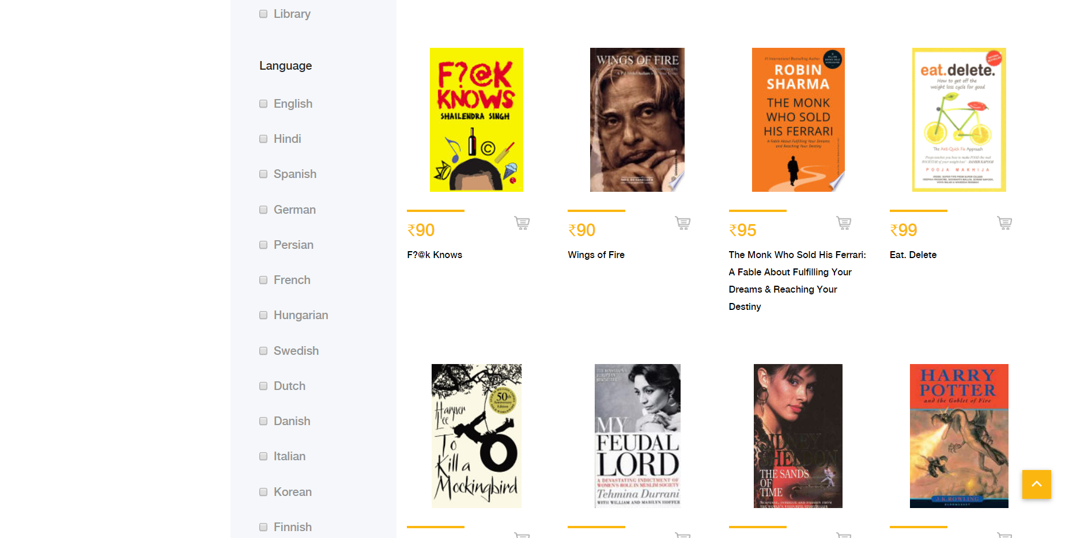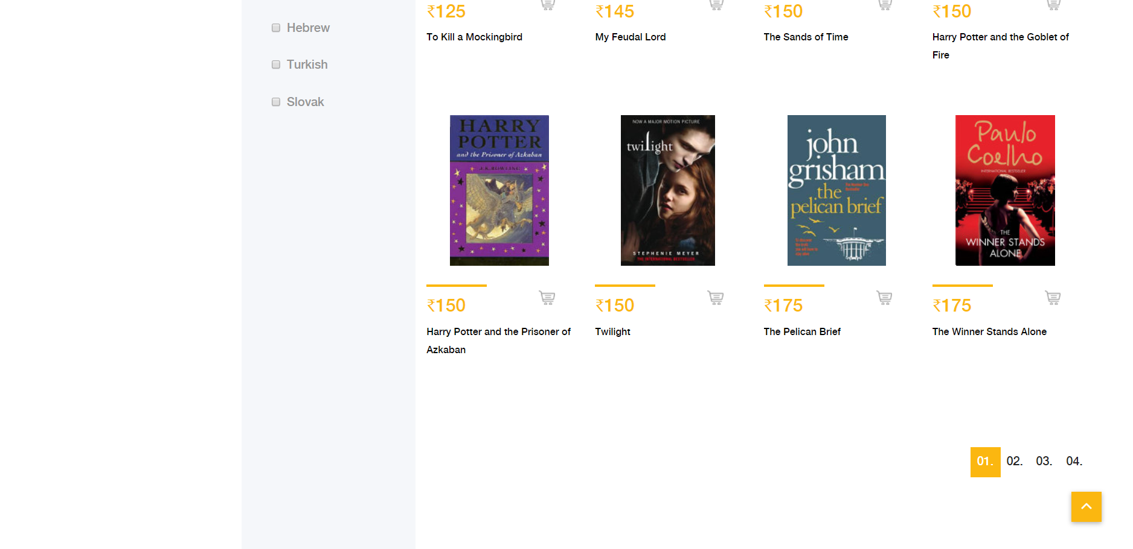

**Mobile view**

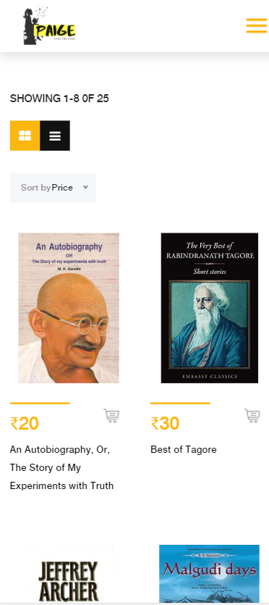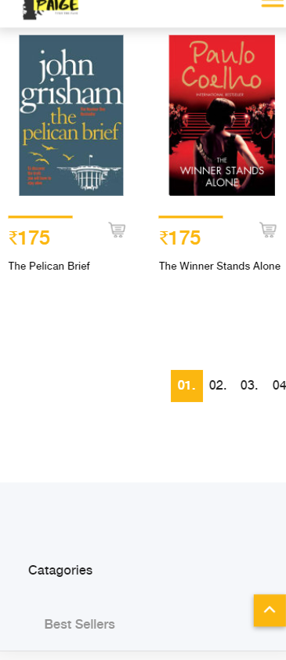

1. User can view all the books on the shop page.
2. Filters like category, price, language etc can be used to find out books of your interest more easily.
3. Sort parameters like price, newest, popular can be used to sort books.
4. User can scroll between pages by the page the page change buttons provided on the bottom of the page.
5. User can click on any book to get its further details.
6. User can also add books to his/her wish list.

**Search**

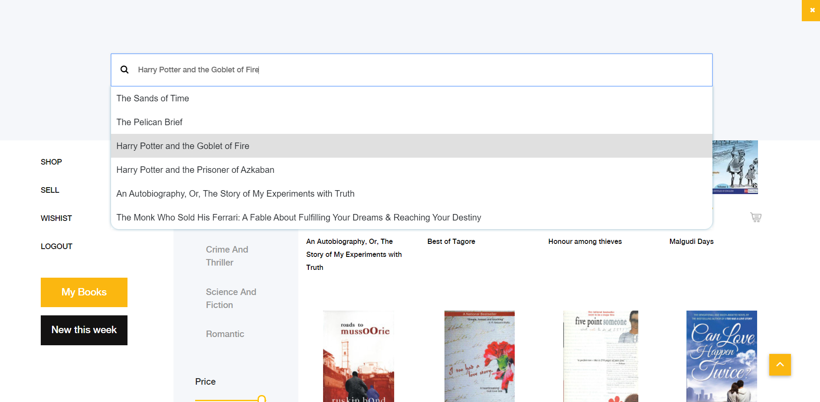

User can also search for books by author, title etc with the help of the search box.

**Product description** **(This page is opened when user clicks on a book.)**

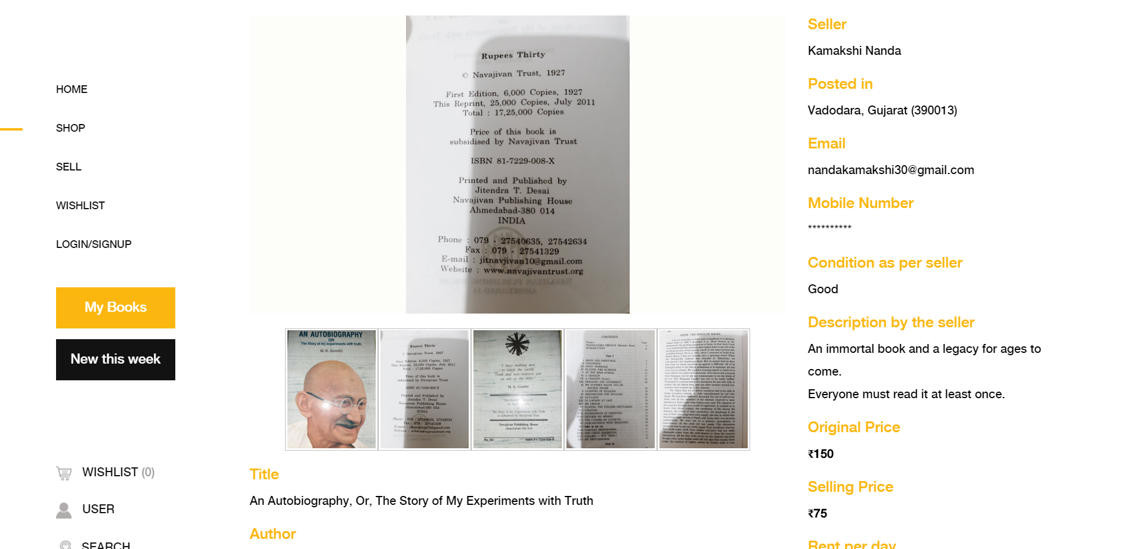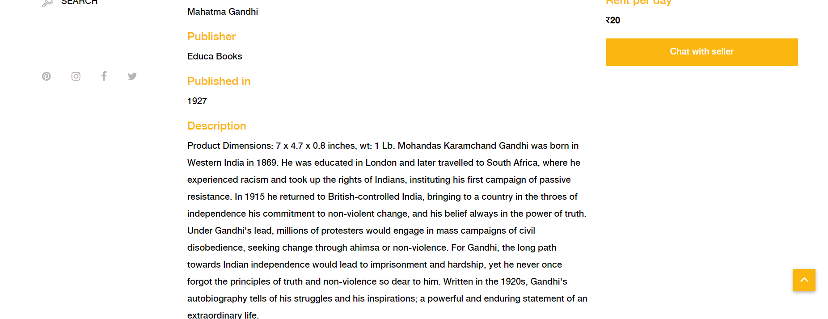

**Mobile View**

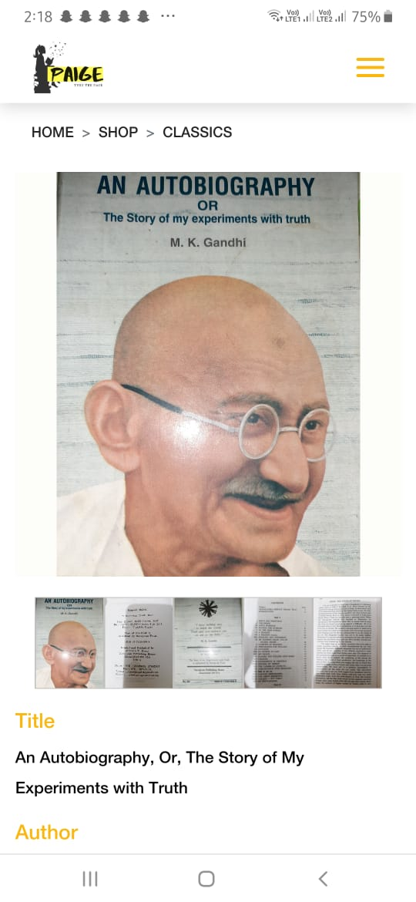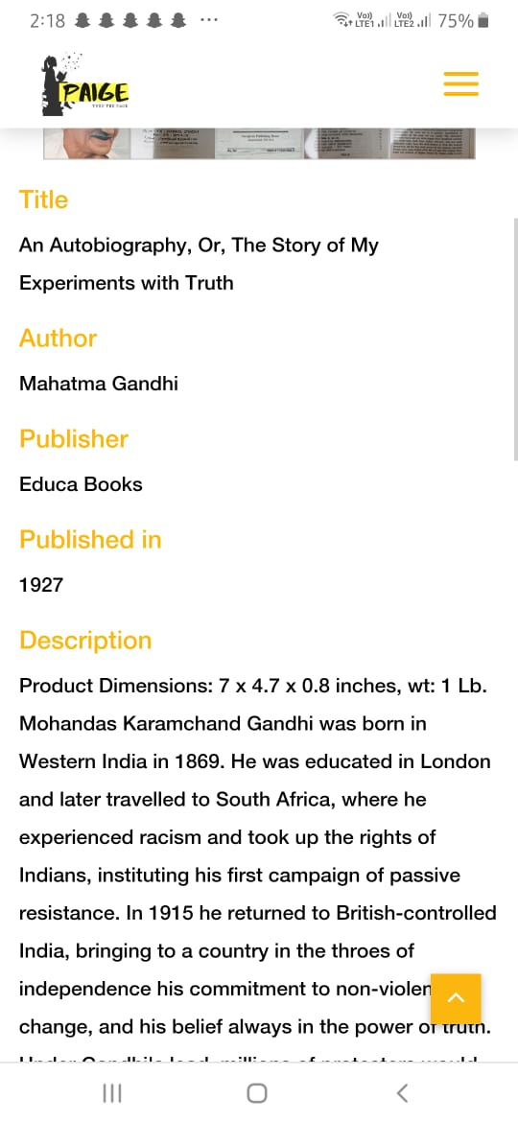

1. User can view description of the book like its author, seller, publisher etc.
2. User can also chat with the seller.

**Sell**

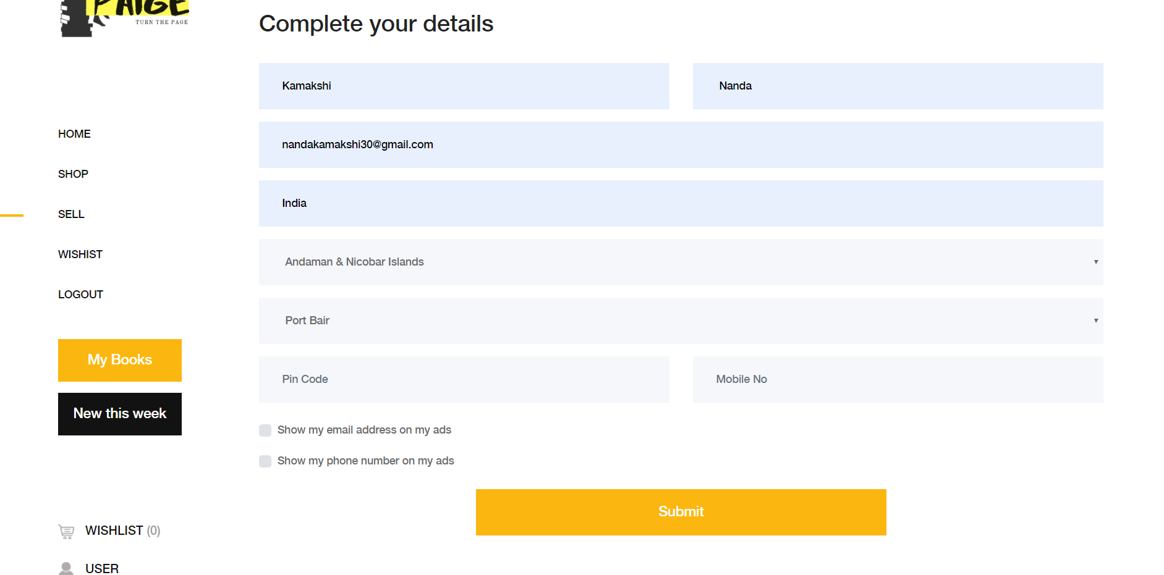

1. To sell a user must Log in into our website, if without logging in user tries to open sell page he/she is redirected to the login page.
2. If a verified user tries to sell a book for the first time, the user is asked to complete details through the above form.

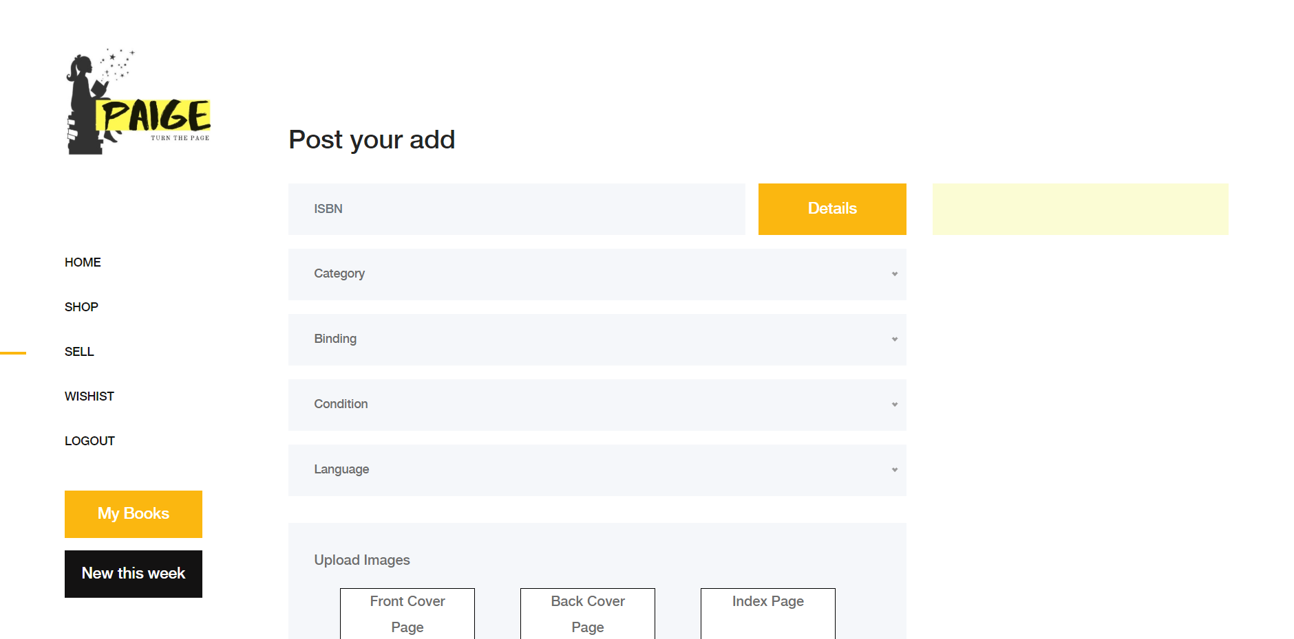

1. Once the user completes his/her details, information about the book to be sold is required.
2. We only ask the user for the user specific book details and its ISBN number, general details are fetched by our application using the ISBN number.
3. User can view the general details of his/her book by the “Details” button.
4. The images of book’s pages uploaded by the user can be of any size, user need not compress those images. User’s images are compressed by our application before storing it into the database.

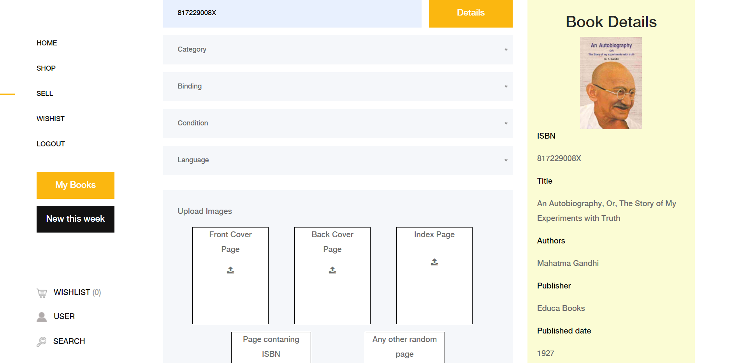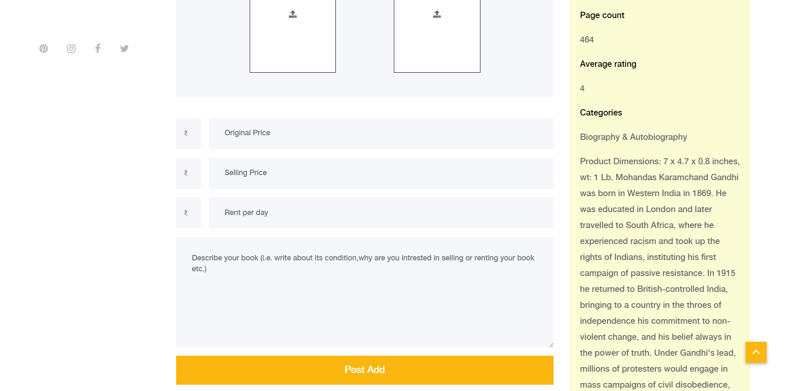

**Wish list**

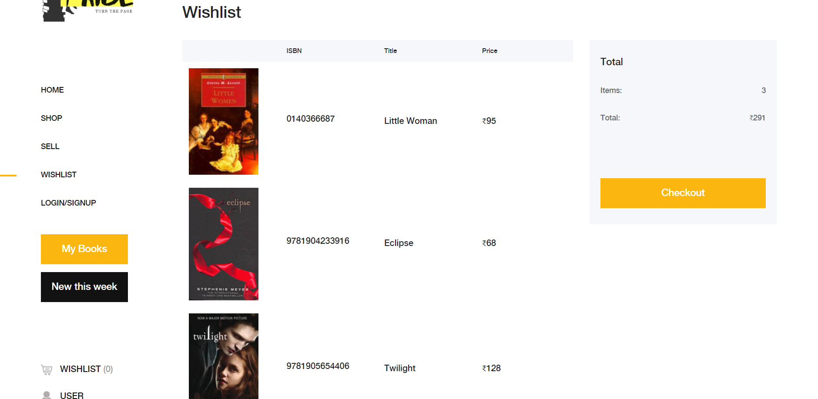

1. User can store and view books of his/her interest into the wish list.

**My Books**

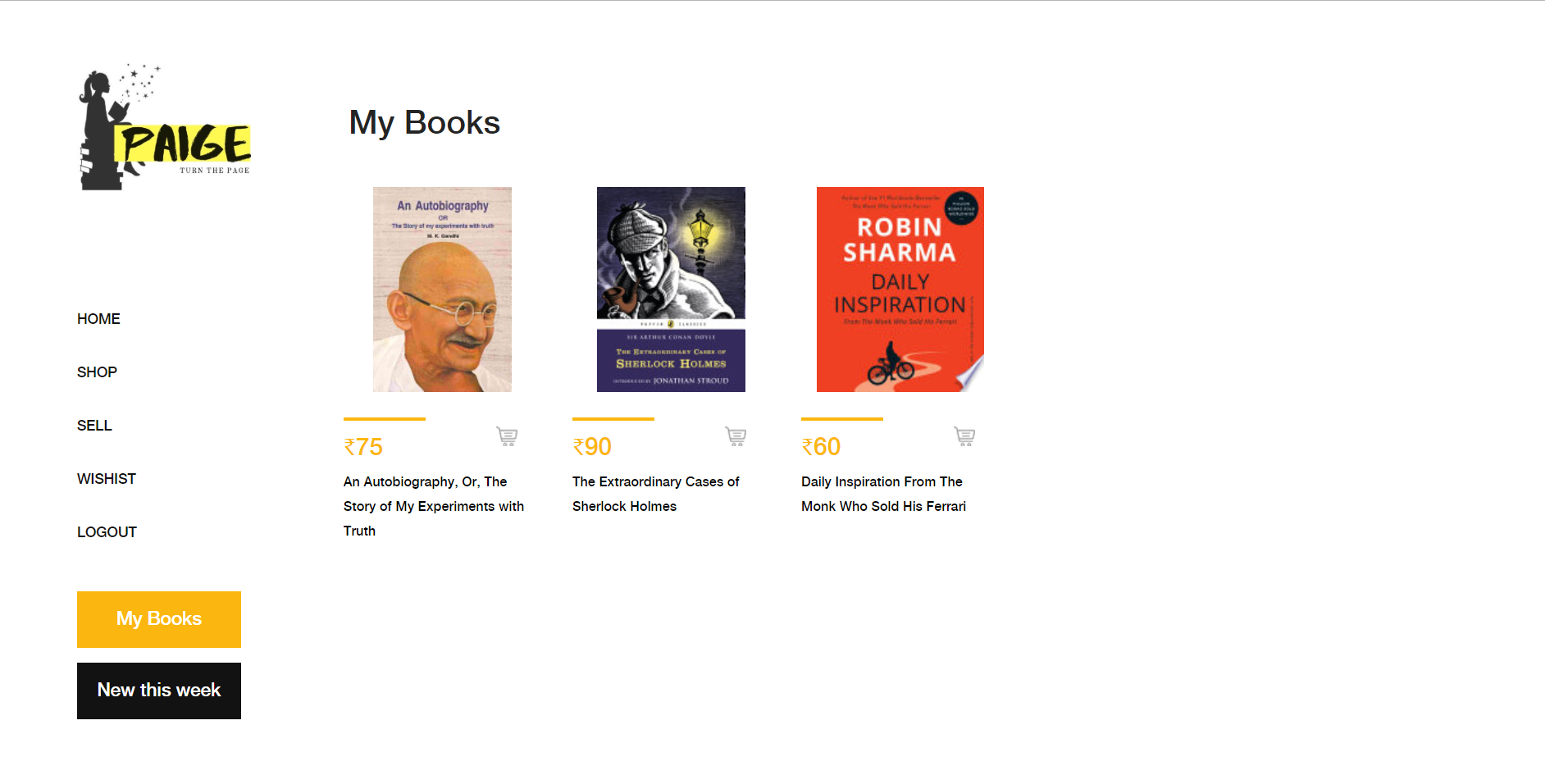

1. User can view books uploaded by him/her on this page.

**User Page**

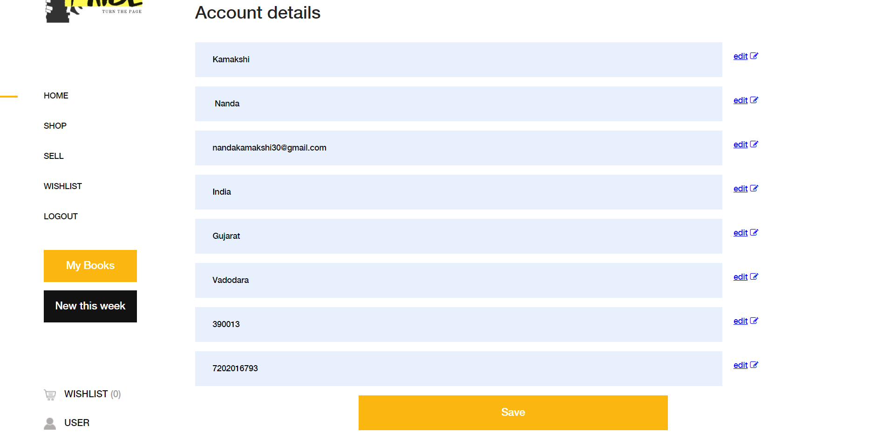

1. User can view or edit his/her details on this page.

**Sign Up**

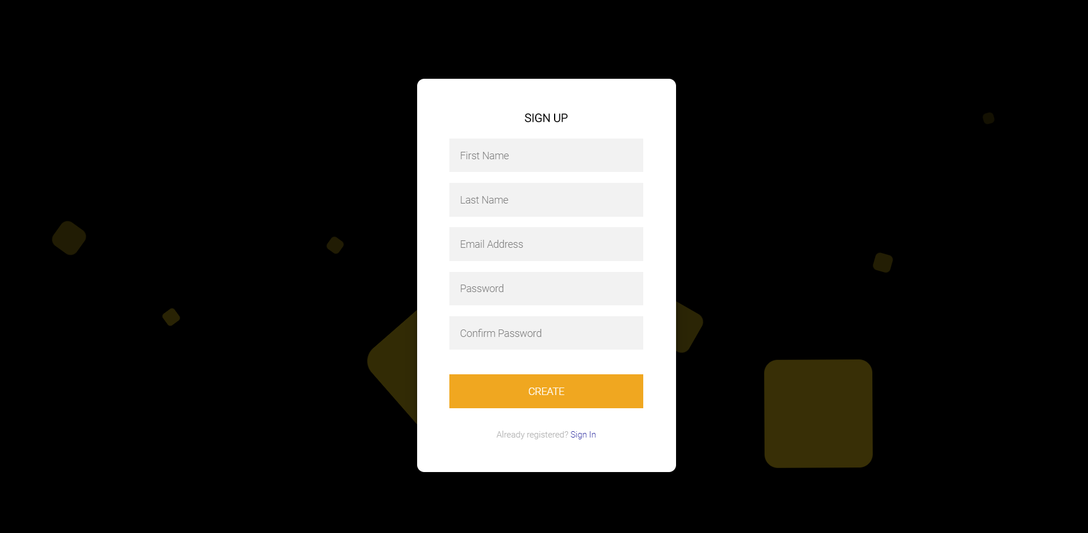

1. User can register himself/herself into our application by creating an account using the above form.

**Log In**

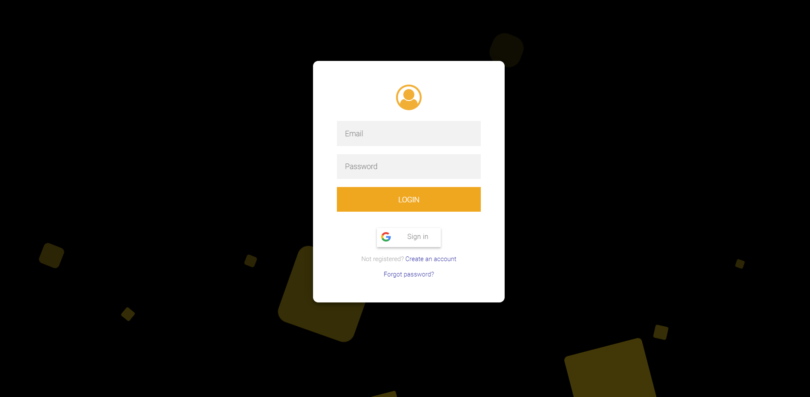

1. User who has created an account in our web application can login through the above form.
2. Or the user can also login through his/her Gmail account with the help of sign in with Google button.
3. User can click on forgot password link if he/she has an account but has forgotten the password.

**Forgot Password**

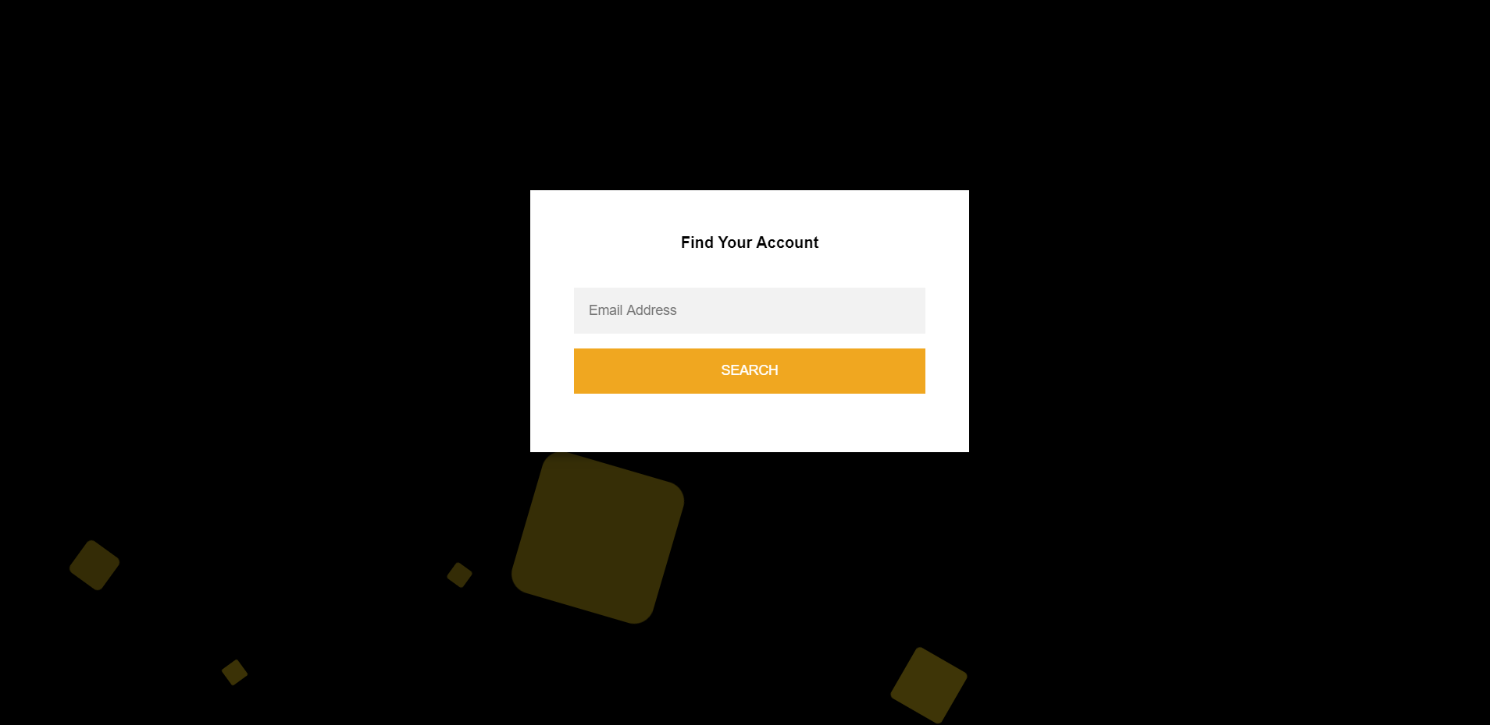

1. User can find his/her account using the registered email address.

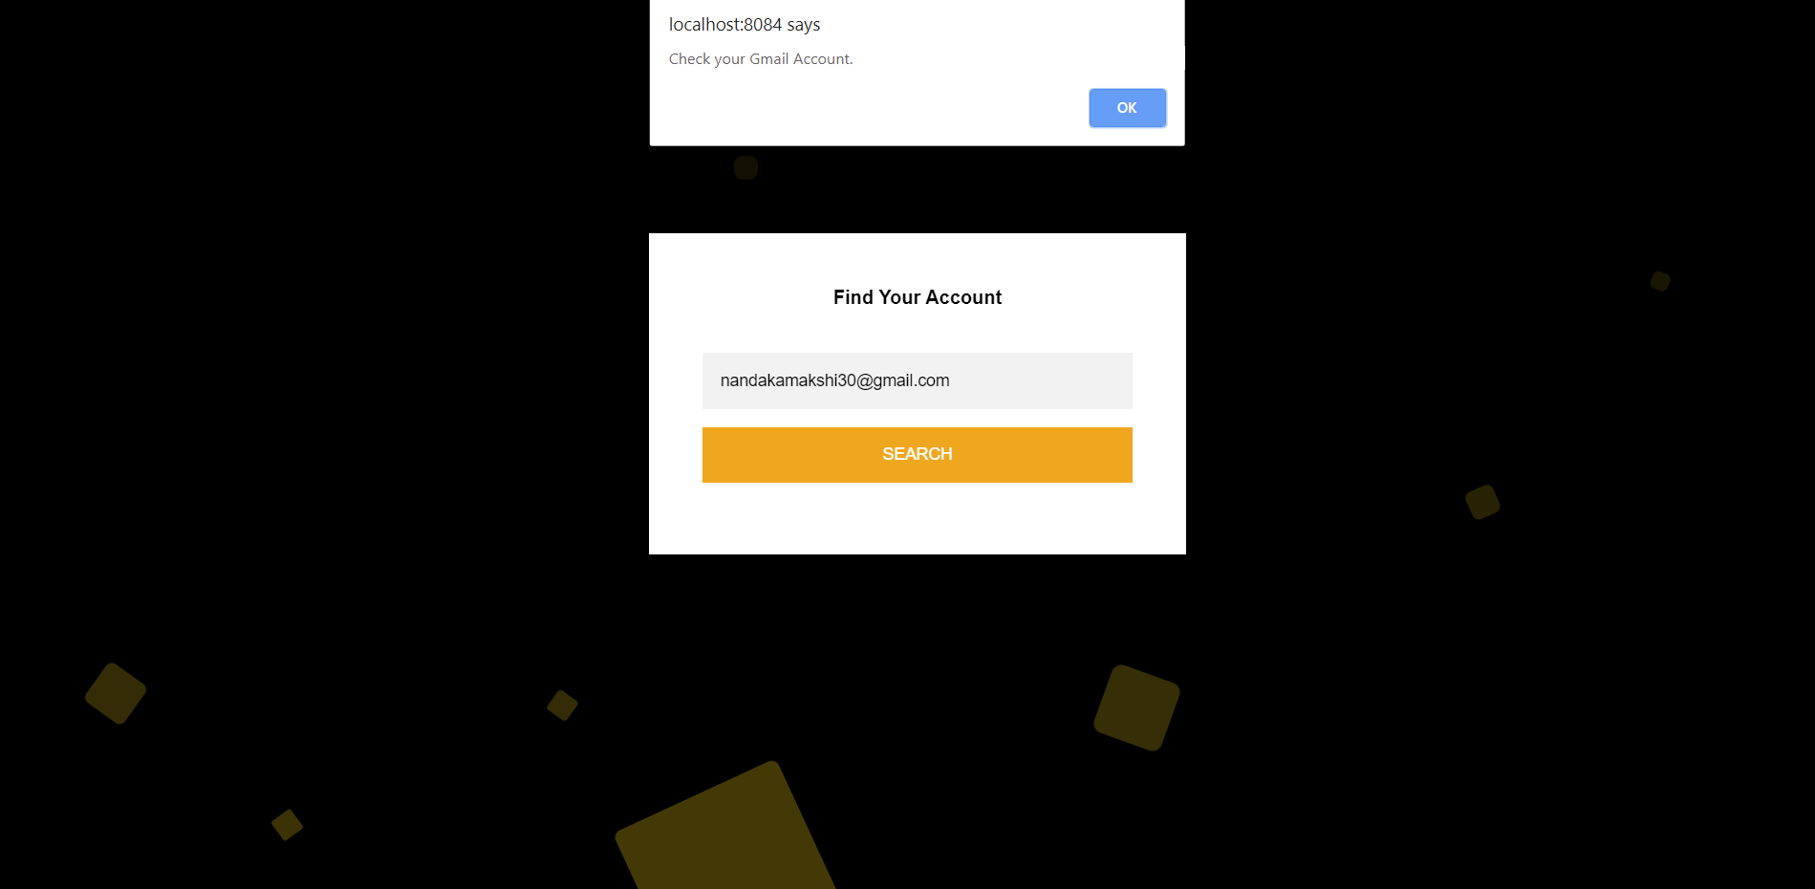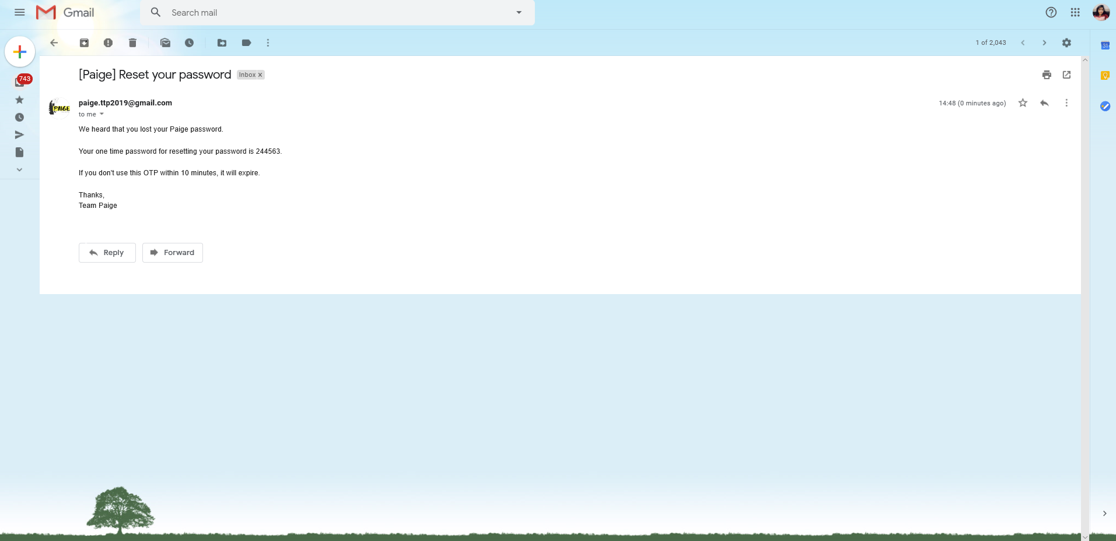

1. An email containing the OTP is sent to their account if the email address is registered.

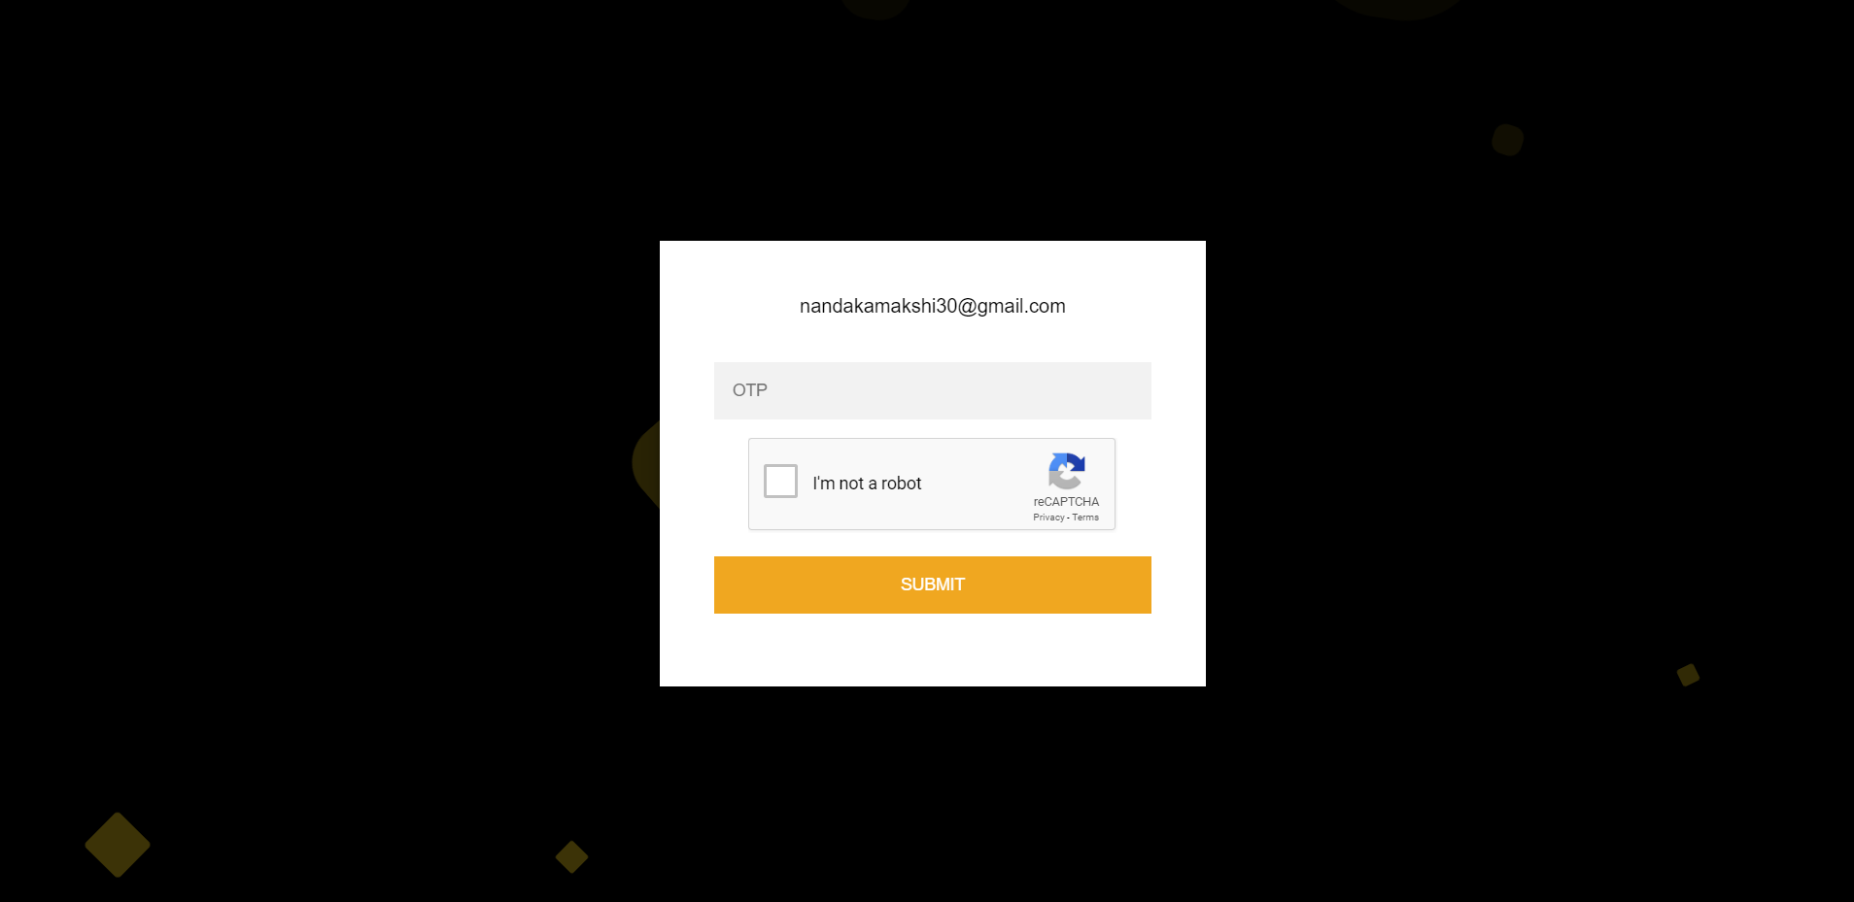

1. User should enter the OTP sent to his/her email address on this page.

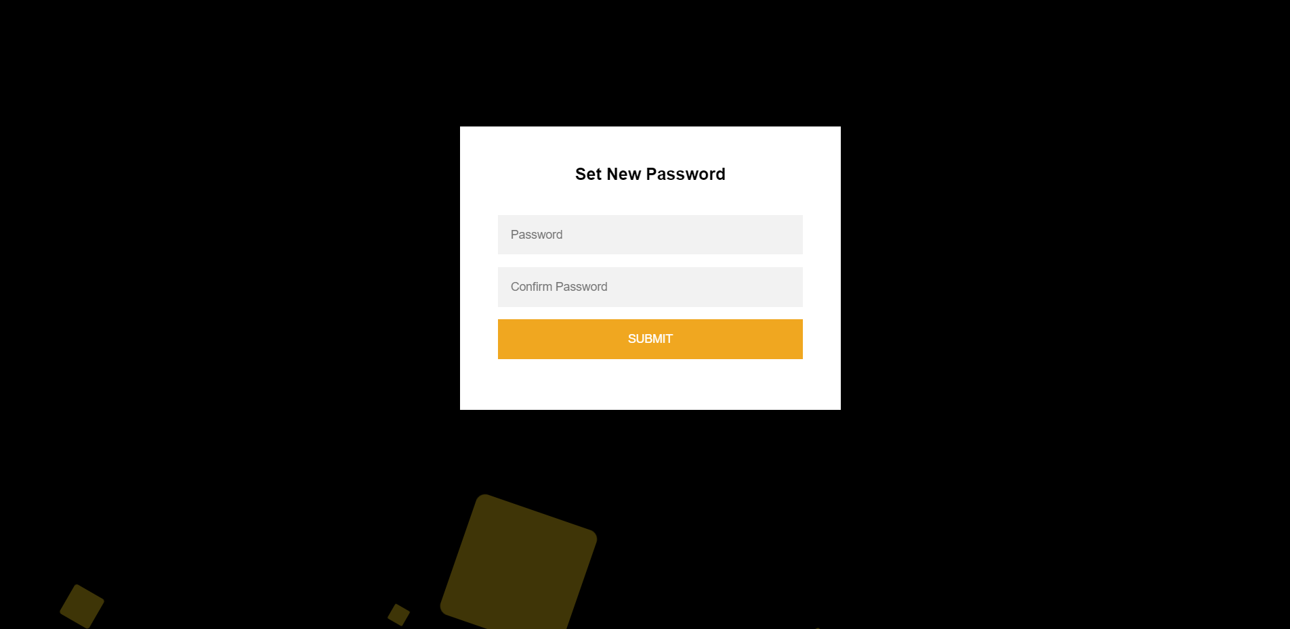

1. Page to reset the password is provided if a right OTP is entered.

**Testing**

* 1. Test Plan
  2. Test methods
  3. Test cases
  4. Bug Fixing/test report

**Security Features**

1. prepared statement to avoid sql injection

2. error page to prevent the server information

3. hash algorithm SHA-256 algorithm used for encryption of sensitive data like password

4. java language for backend which provides many safety features itself

5. use of SSL protocol for hosting

6. use of recaptcha in many forms to avoid attacks like cross site request forgery attack

7. use of one time password (OTP) to authenticate the user

**Coding standards Followed**

1. Indentation:

Proper and consistent indentation is important in producing easy to read and maintainable programs. Indentation used to:

• Emphasize the body of a control statement such as a loop or a select statement

• Emphasize the body of a conditional statement

• Emphasize a new scope block

* Indentation used in a loop construct.
* Indentation used in the body of a method.
* Indentation used in a conditional statement.

1. Inline Comments

Inline comments explaining the functioning of the subroutine or key aspects of the algorithm are used.

1. comments.
2. Structured Programming

Structured (or modular) programming techniques are used.

1. Classes, Functions, and Methods

subroutines, functions, and methods are reasonably sized depending upon the language being used. The names of the classes, subroutines, functions, and methods have verbs in them.

1. Source Files

The name of the source file or script represent its function. All of the routines in a file have a common purpose.

1. Variable Names

Variable have meaningful names that convey to a casual observer, the

intent of its use. Variables are initialized prior to its first use.

1. Use of Braces

braces are used to delimit the bodies of conditional statements,

control constructs, and blocks of scope.

1. Compiler Warnings

Compiler warnings do not stop the compilation process. However, compiler errors do stop the compilation process, forcing the developer to fix the problem and recompile.

1. Line Length
2. Spacing

The proper use of spaces within a line of code to enhance readability.

1. Wrapping Lines

• Break after a comma

• Break after an operator

• Higher-level breaks to lower-level breaks

**Limitations and Future Enhancements**

1. **Limitations:**

* The system is limited to domestic users only.
* System doesn’t provide any history details or summary of the books sold or rented to the users.
* System fails to detect the exact quality of books if the users upload edited pictures.

1. **Future Enhancements:**

* Artificial Intelligence: identify the original quality of book using AI.
* Make the system available to users globally.
* Provide a history pane

**Experience and learning**

Building a whole system from scratch considering all the aspects of software engineering from gathering requirements to planning, designing, proposing the project plan, defining the scope, modeling, analyzing the design, coding, building a database for a whole system, testing was a lifetime experience in itself.

Building a website for a client, working with database, server, interface design, backend coding, assembling everything to get the final output under the guidance of our client and the project guide taught us how different is the real world, working in team made us realize the importance of team spirit, unity and patience. We faced many difficulties but having a mentor/guide makes everything much more easier, every time we were stuck somewhere our guide was there to help us, challenged us to solve the queries on our own and in the end always used to give us the best solutions.

We learned to solve real problems, learned lot of new techniques and technologies during this period. This project helped us to get out of our comfort zone, learn new technologies and their implementations.

We also learned how to deal with a client. How to elicit requirements from the clients, stake holders and all the perspective users of the system. We learned to design and model the system. We learned to make various system diagrams such as behavioral diagrams, class diagrams, entity relationship diagrams. We learned and experienced how to present the prototypes. For the first time we created test cases for a system made by us and made others test the prototype.

These 4 months were a roller coaster ride for us consisting of knowledge gain, experience, life lessons, team work, real time dealing. We can’t thank enough our client and the department for such an amazing experience.

**References and Bibliography**

* <https://www.olx.in> , <https://www.bookchor.com> – referred for the basic idea of the system
* <https://www.w3schools.com> –referred for bootstrap tutorials and interface designing
* <https://bootstrapious.com/tutorials>
* <https://www.uml-diagrams.org/sequence-diagrams.html> - for uml diagrams
* <https://www.smartdraw.com/uml-diagram/> - for uml diagrams
* <http://iiti.ac.in/people/~tanimad/JavaTheCompleteReference.pdf>-JAVA complete reference seventh edition